Revegetation alliance to boost Tweed koala habitat
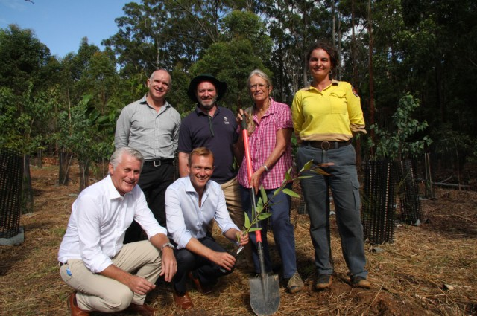
NSW environment minister Rob Stokes (with sapling) and Tweed MP Geoff Provest (front left) ready to plant a seedling to launch the project to further revegetate Cudgen Nature Reserve, watched by project manager and research fellow at Southern Cross University Kevin Glencross (top left), Tweed mayor Gary Bagnall, Friends of Cudgen Nature Reserve volunteer Rhonda James, and National Parks and Wildlife Service acting area manager Jenny Atkins. Photo supplied
A combined effort by community and other agencies in a $200,000 project to restore 23 hectares of former banana farming land at Cudgen is set to increase much-needed habitat for endangered koalas on the Tweed Coast.
The initiative was launched by state government, Southern Cross University (SCU) and community members at Cudgen Nature Reserve last Friday. The project is funded by the federal government through the Subtropical Farm Forestry Association, which is coordinated by Southern Cross University.
Tweed Shire Council staff were also involved in the launch of the project to plant 15,000 koala food trees at the reserve, recognising the initiative’s links to the Koala Connections program by the Tweed and Byron councils.
The Koala Connections project recently planted 5,000 native trees in the nature reserve, as part of the program’s aim to improve koala habitat corridors in public and private land along the coast.
That work will be complemented by the latest joint program between SCU, the National Parks and Wildlife Service, WetlandsCare Australia and the Friends of Cudgen Nature Reserve to restore the 23 hectares of land formally occupied by banana farms.
The launch for the site restoration was kicked off by NSW environment minister Rob Stokes and Tweed MP Geoff Provest when they planted the first of the seedlings.
Koala Connections project manager Scott Hetherington welcomed the latest project, saying it would further strengthen the site as koala habitat and complement other koala conservation initiatives planned for the location.
‘This announcement comes soon after another Koala Connections initiative to alert motorists by implementing koala zone signs on Clothiers Creek Road at each end of the nature reserve,’ Mr Hetherington said.
‘While the signs on the road surface aim to raise driver awareness and reduce the number of koalas killed by traffic on that road, there are several other steps we’re currently finalising as part of an overall koala road package.
‘The intention is these packages could then be implemented on other designated koala roads, throughout our district and beyond,’ he said.
Tweed mayor Gary Bagnall also attended the launch, saying that Mr Stokes ‘has taken a keen interest in our shire and in particular the Tweed Coast’s koalas’.
‘This grant will be of enormous value to our efforts to save the last of our koalas from extinction’ Cr Bagnall said.

