Friends of Cudgen Nature Reserve
Community Koala Habitat Planting Day the 7th April 2018.
Our last work day was successful with some weeding and an inspection of two parts of the Cudgen Nature Reserve rehabilitation our group has been undertaking.
Our next two work days coming up include: a small planting & weeding work this coming Saturday the 10th March and community planting 7th April.
The Community Planting on 7th April we plan to plant 200 trees to continue the extension of Koala Habitat plantings in Slip Rails Rd section of the Reserve. This follows earlier community plantings at this site organised by Conservation Volunteers Australia. The Community Planting is supported by Tweed Shire Council, supplying the trees and NPWS Murwillumbah.
Any Landcarers interested to come along for the April planting are more than welcome.
Meeting Point: We will meet at Slip Rails Road and then ferry people to the 1st gate along Clothiers Creek Road as there is not enough parking at the site.
Time: Both Work Days Meet @ 8.00am then work for approx. 2-3hrs. Morning tea will be provided afterwards.
What to Bring: Sturdy shoes, preferably long pants, water, sunscreen, insect repellent and a hat. We can provide gloves if you don't have any.
Please contact Chris Core on 0407 762108, or John Mc Donagh on 0421 657 960 (or email jngmcdonagh@hotmail.com) if you have issue finding the meeting point or require any further information.
(Attached are three photos FYI photo 1 The second Slip Rails CVA planting last March & photo 2 the same area last month – our group will continue the rehabilitation of this site with the April planting for Koala Habitat & Erosion Control purposes. Photo 3 is the Clothiers Creek Rd site last month).

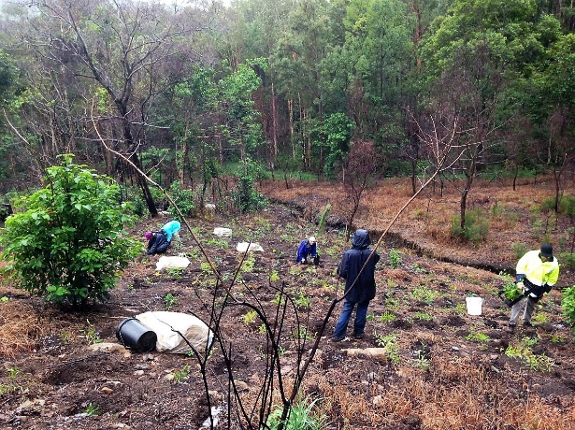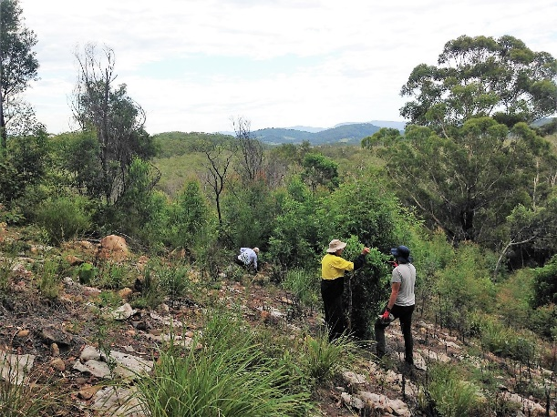
March 2017 Planting Day Slip Rails Site March 2018 Maintaining the Slip Rails Site
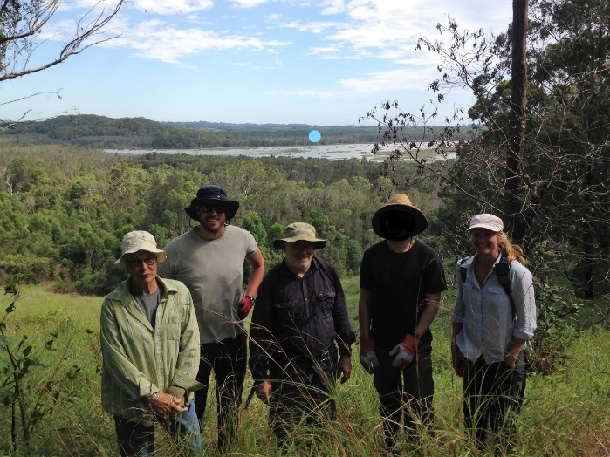
March 18 Inspection of Clothiers Ck Rd Site

