Mount Saint Patrick College

STUDENT NETBOOK

USER MANUAL
2015

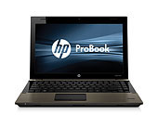
2015-2017
HP430 G2 Probook laptop computer

DO’s
- Do place your Netbook on a flat, stable surface when in use
- Do backup your data regularly
- Do use on a stable surface
- Do store your Netbook within its hard cover carry case
- Do carry your Netbook with the strap across the shoulders when using the shoulder strap on the carry case
- Do charge your Netbook overnight – leave your power cord at home
- Do make note of any error messages for tech support
- Do only use in environments between 5 and 35 degrees

DON’Ts
- Don’t loan your Netbook to anyone or let anyone else use it
- Don’t place on uneven or unstable work surfaces
- Don’t place any paper or objects on the keyboard on close the lid on any such objects
- Don’t place or drop objects on top or foreign objects into the device
- Don’t expose to dirty or dusty environments
- Don’t expose to strong magnetic or electrical fields
- Don’t press or touch the display panel
- Don’t pick up or hold or carry the Netbook by the display panel
- Don’t expose to or use near liquid, rain or moisture
- Don’t carry or cover a Netbook that is powered on
- Don’t use damaged power cords, accessories or other peripherals
- Don’t use strong solvents or chemicals on or near the surface
- Don’t spill food or drink on your Netbook

MT ST PATRICK COLLEGE RULES FOR NETBOOK COMPUTER USE

- The device is a school device and is to be used primarily for school work in accordance with the College Computer Network Policy Agreement which all students have signed
- Students are to bring the Netbook computer to the College every day except special events days, like the Swimming Carnival and the Athletics Carnival
- The device is not to be taken to sport. It is to be stored in the designated area within the College buildings and retrieved in Homeroom administration time at the end of the day
- The device is not to be used in the College grounds before or after school or at recess or lunchtime. Apart from class time, the only other use of the device will be at lunchtime in the library
- The device must be brought to every lesson during the school day
- When the device is used in class it is to be used under the direction of the teacher
- The web camera and recording features on the device are not to be used at school, unless instructed by the teacher
- Students are required to back up their school work files regularly to protect their work from loss or corruption (private files should also be backed up)
- Students are to charge their battery every night ready for use during the next school day
- The device is not to be physically vandalised or interfered with in any way
- Software installed by the College is protected by copyright and must not be redistributed or deleted
- Students must not alter or modify the original pre-set software image, change the computer name, alter the security software or remove any operating system extensions
- Students are not permitted to use or interfere with another student’s device in any way
- Each student is responsible for the appropriateness of all files on their device. This is ensured by logging on with the unique account and password credentials that you have been given and by not making the device or the logon details known to anyone else. If you suspect that your security has been compromised in any way you must immediately report the fact and proceed to the Help Desk for a renewal of your account and password details.
- Illegal or unacceptable files or software applications must not be installed or saved on the device. This includes images, videos, music, games, etc with adult or degrading content and material that promotes anti-social attitudes, violence, discrimination or bullying.
- When not in use, the device must be stored within its protective case.
- Students are not to remove or deface any identification labels on the device. Students are permitted to personalise the device with a single appropriate sticker. Irreversible personalisation is not permitted (no engraving, liquid paper or other permanent markings)

Failure to follow the College Rules for Netbook Computer Use may result in confiscation of the Netbook and detention or further sanctions (eg termination of the student’s MSPC intranet account or exclusion from access to the internet at the College) as determined appropriate by the Learning Technologies Coordinator or Principal.
Random audits of student devices will be performed on a regular basis by College Network Support Officers. Students will be held responsible for any inappropriate or unacceptable files or illegal software found on their device. There may be situations when a device will need to be re-imaged. If the device is re-imaged, any files that the student has not previously backed up safely will not be able to be recovered.

Health and Safety considerations when using Netbooks

- Sit on a chair at a desk. This is especially important if using a Netbook for longer than 30 minutes.
- Keep a good posture. Adjust the chair and Netbook for a “neutral” posture. This means ankles, knees, hips and elbows are at about 90-degree angles and hands are in line with wrists.
- Relax arms, neck and shoulders. Most muscle strain centres on arms, neck and shoulders so try to keep these relaxed. Typing and using the mouse should be light, and hands and arms rested when not typing.
- Don’t sit too close to the screen. Sit about arm’s length from the screen, depending on individual eye conditions.
- Take regular breaks. Take 5 minutes out of every 30 minutes to rest both eyes and muscles
- Stay safe on-line - It is essential that parents, carers and students visit the special government websites at www.cybersmart.gov.au and http://www.staysmartonline.gov.au/ and the Federal Police website at http://www.afp.gov.au/ to familiarise themselves with many of the important recommendations regarding safe use of computers and cyber safety issues.

Caring for your Netbook

You are expected to treat your Netbook with care and respect. The Netbook and College issued sleeve are the property of Mt St Patrick College and should be kept clean and free of marks at all times. Personalisation of the Netbook is allowed. Remember, that irreversible personalisation is not permitted such as engraving, the use of liquid paper and other permanent markings.

The Netbooks have a ‘sleep mode’. Press the F5 key or close the screen to put your Netbook to ‘sleep’. When the Netbook is in this state it will use very little power and will extend your battery life.

To reactivate your Netbook – press the power button once. The Netbook will be in a ‘locked’ state and you will need to re-enter your password to log-in. It is recommended that students lock computers before putting in sleep mode.

Packing away your Netbook
- Handle your Netbook with care.
- Always store your Netbook safely in your Netbook case, when travelling to and from the College. Store your Netbook in a vertical position, away from liquids, in your Netbook case.
- You still need to be careful with your Netbook while it is in the case. Do not drop the bag from your shoulder. Always place the Netbook bag down gently.
- Netbooks should be logged off, closed down and switched off before being placed into the case.
- Be careful when putting the Netbook in the car that no other items are on top of it and nothing will roll onto the bag.
- Do not wrap the cord around the power adapter or the cord will become damaged.
- Try to avoid moving your Netbook around when it is on. Before switching on, gently place your Netbook on a stable surface and then switch on.

Operating conditions

- Put the Netbook on a solid surface if you are using it for a long time. Resting it on a pillow or other soft material might block the airflow vents and cause overheating.
- Please don’t place objects on top of your Netbook and never carry it around while it is turned on.
- Avoid exposing your Netbook to:
- Direct sunlight or sources of heat such as desk lamps.
- Dust, dirt, rain, liquids or moisture.
- Heavy shock or vibration.

LCD screen

LCD screens are delicate – they don’t like being poked, prodded, pushed or slammed. Never pick up your Netbook by its screen. Don’t slam the screen closed and always be gentle when putting your Netbook down. Never close the screen if there is something on the keyboard.

To clean your LCD screen:
- Switch off your Netbook.
- Lightly dampen a non-abrasive cloth with water and gently wipe screen in a circular motion.
- Do not directly apply water or cleaner to the screen.
- Avoid applying pressure to the screen.

AC adapter

- Connect your adapter only to your Netbook.
- Find a safe location at home to recharge your Netbook. Disconnect the power supply from the wall when not charging your Netbook – this will prolong the life of the unit.
- Do not step on your power cord or place heavy objects on top of it. Keep your cord away from heavy traffic areas.
- When unplugging the power cord, pull on the plug itself, rather than the cord.
- Do not wrap your cord around the adapter box.

Keyboard

- Gently brush your keyboard with a clean soft bristled paint brush or similar to remove dirt.
- If any key tops are missing or keys are in a damaged state, take your Netbook to the Helpdesk to be repaired immediately. A single key top can easily be replaced but continuing to use the keyboard with a missing key top can result in having to replace the entire keyboard.

Technical support

The College has a Netbook Helpdesk Centre (Helpdesk) within the College. If you are experiencing problems with your Netbook, your first step is to troubleshoot the problem yourself. More often than not, you will be able to resolve most software issues. A troubleshooting section for a range of common computer problems can be found at the end of this manual.

If you experience persistent hardware or software issues, you must log a Helpdesk ticket for the problem by accessing the link on the College Moodle Homepage as soon as possible. If your Netbook cannot be used to log the ticket, you can use a computer in the Library or a laptop in the Helpdesk foyer. Helpdesk tickets can be submitted from home also. Please note: there must be no attempt to repair the Netbook as this will void the manufacturer’s warranty. Once the fault has been submitted via a Helpdesk ticket, you are to await a reply from the Helpdesk where you will be informed about what to do next.

If a problem cannot be fixed within a set period of time by the Helpdesk, the Netbook will be re-imaged and returned to its default settings. It will be your responsibility to ensure a backup of all data has been done prior to the re-imaging process.

Students are only permitted to attend the Helpdesk before school, at recess and at lunch time. You will not be permitted to attend the Helpdesk after class bells have sounded. In emergency situations a student may need immediate attention and may be sent by a teacher to the Helpdesk. Any student who attends the Helpdesk during class time MUST have the teacher’s written consent in the appropriate page in the diary.

Please note: The Helpdesk is NOT responsible for backing up any student work. This must be carried out by you at regular intervals and before bringing a Netbook in for servicing.

Battery life

The Netbook is capable of lasting a normal College day on battery power alone. The power supply must remain at home in a safe place. You will need to recharge your Netbook overnight, every night, ready for the new College day.

There will be NO provision for recharging the Netbook at the College. This is an OH&S issue. The only exception to this rule is when the battery has failed to retain its charge for the full day and this is only likely in the third year of its life or when the battery is faulty. A faulty battery can be replaced on warranty for one year – a Help Desk ticket is needed. To charge the laptop at school, go to the Library or Help Desk at lunch time.

Backup / recovery

Students will at all times be responsible for the backing up of all data on the Netbook. Essential school files should be backed up in the student’s Home drive on the College file server as usual.

Parents/caregivers should purchase a reliable backup storage system at home for school data and also for personal data. This could be an external hard drive or DVD drive. Flash drives / USB sticks are not reliable as a permanent backup method, but they are good to use as a temporary backup device or as a transfer device to move data from one source to another.

Students have been very forgetful regarding backing up important work. You need to develop a habit of backing up your My School Work folder regularly. The loss of files will be no excuse for the failure to submit assessment work. See your teacher for assistance with back up procedures if needed.

Virus Protection

Viruses have the potential to severely damage and disrupt operations within the College computer network. As students have the right to personally use their Netbooks, and connect to the internet from home, they should take all steps to protect the College’s computer network from virus attacks.

Viruses can enter Netbooks through:

- Removable media such as CDs, DVDs, floppy disks and USB memory sticks
- Emails
- The internet (including web browsing, FTP programs and chat rooms)
- File downloads/network file shares, such as servers and shared folders

Tips to protect from virus infections:

- Protect your Netbook from virus attacks by scanning your computer for viruses at least weekly. Microsoft anti-virus updates are updated automatically every time you log on to the College network.

- Consider carrying out a virus scan of your Netbook after you have accessed the internet, personal mail or opened a file from a removable media source. You should carry out the scan before returning to the College and connecting to our network.

- Do not open any files attached to suspicious or unknown emails.

- Exercise caution when downloading files from the internet. Save the files to the Netbook hard disk and run the virus scanner on the file before opening them.

- Delete chain and junk emails. Do not forward or reply to any of these.

- Never reply to spam. Spam email messages can contain viruses that notify a third party of the legitimacy of an email address and then add the recipients to the spammer’s database. They can also consume a large amount of disk space on the server which slows computer networks.

- Hundreds of viruses are discovered each month. Run your virus scan regularly.

Carry Cases / School Bags

The Netbook must at all times be stored within its protective carry case. This includes when moving between classes, when the Netbook is in your desk or locker, or when it is in your bag whilst travelling to or from the College. This should keep the Netbook safe from accidental damage. We expect that your laptop will be in good condition when you take it at the end of the 3 year loan period at school and this will be the case if you follow the College rules that protect it.

Security / Storage

The Netbooks are to be securely stored within your desk or locker while at school or kept with you during lesson times. When the Netbook is in your school bag (e.g. travelling to and from school) you should ensure that your school bag is:
- securely closed at all times with the Netbook in its protective case
- kept dry and away from liquid at all times
- not placed in a high traffic area where it could be stepped on or present a trip hazard
- not sitting in direct sunlight or exposed to extreme weather conditions
- within your possession while in public

Lost and Found Policy

The College must be notified immediately if a College-owned Netbook is lost or missing – refer to the section on ‘Damage or Loss of a Netbook’ in the ‘Netbook Computer User Terms and Conditions’ document.

All found Netbooks will be handed into the Helpdesk and the technician will return the Netbook to its designated owner. If the Netbook was lost at College the student must report to the Helpdesk to check if it has been found. If the Netbook is not at the Helpdesk, the matter will be directed to the Learning Technologies Coordinator for further action.

Loan / Replacement Netbooks

The Helpdesk will manage all loan and replacement Netbooks.

Loan or replacement Netbooks will be provided under the following circumstances:
- When your Netbook is away for repair under warranty as arranged by the Helpdesk.
- An authorised repair, scheduled upgrade or reinstallation which exceeds 3 days.
- When your Netbook has been stolen and all insurance conditions have been considered.

Appearance / Personalisation

Netbooks will be clearly labelled with your name on the front cover with the workstation designation on the underside of the Netbook. You are not to remove these labels or write anything on them.
You are permitted to personalise the appearance of your Netbook with one appropriate sticker, a personalised cover or a protector. However, irreversible personalisation is not permitted such as engraving, the use of liquid paper and other permanent markings.

Basic Troubleshooting

Experiencing hardware faults?
A HELPDESK ticket must be created using the College Moodle link as soon as possible, taking note of any error messages that may have appeared. All error messages need to be written on the Help Desk ticket when seeking assistance. You will need to explain what you are doing at the time of an error message. For example: installing software, surfing the internet etc.

At no time should you or anyone else attempt to repair the Netbook. NO EXCEPTIONS. Any attempt to fix the Netbook will void warranty.

Experiencing software faults?
Software support will be provided for College supplied software only. Any issues with private software installed will be the student’s responsibility. Any private software that causes conflict with the operation of the Netbook will be removed.

Connecting to your home network:

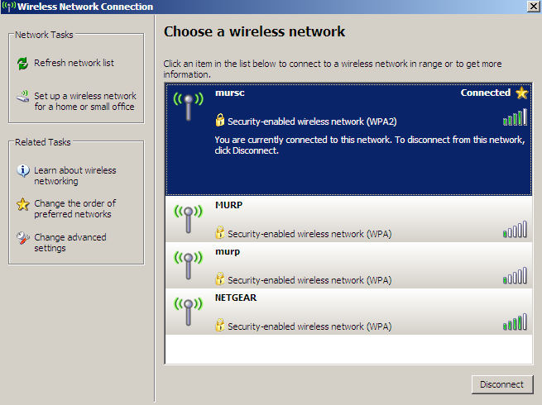
Connecting to a wired home network
Connect a CAT 5 cable to your Netbook and connect to your router.

Connecting to a wireless home network
At home you will need to have the wireless router on and be logged into your Netbook. It will automatically pick up if a wireless network is available. To connect to your home wireless network follow these instructions.
A prompt will show in the bottom right hand corner of your screen, click on it and all available wireless networks will show. You will need to highlight your specific network and select “connect”.

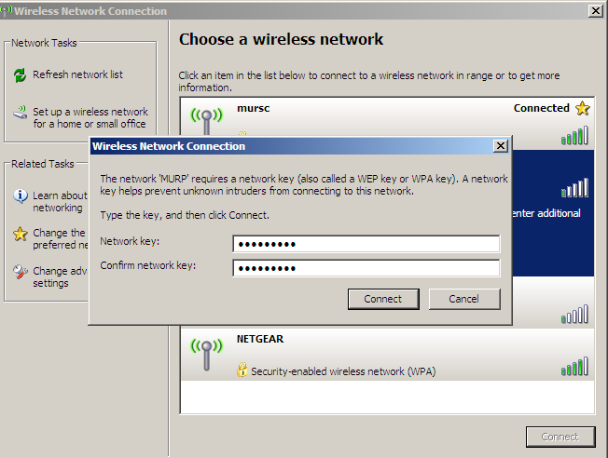
If your wireless is secured you will need the password. Your parents/carers should be able to enter the password, hit connect and you will have access to the wireless. You should only need to do this once – the Netbook will store the password for future access.

When you return to school, the Netbook will detect the school network and connect automatically.

Internet Download Quota at School

The College supplies, at great cost, a broadband fibre optic connection to the internet so that our 800+ users can access the internet with good speed. Students who use the internet excessively, cause costs to blow out and they slow the internet down for all the other users on our network.

To ensure a consistent delivery of internet services to the College, a download quota has been implemented. Any student who exceeds this quota will be automatically excluded for the rest of the day.

