INCLUDES A PROJECT PLAN TEMPLATE
Right from the start!
A guide to planning
best practice Sustainability Education and Engagement projects

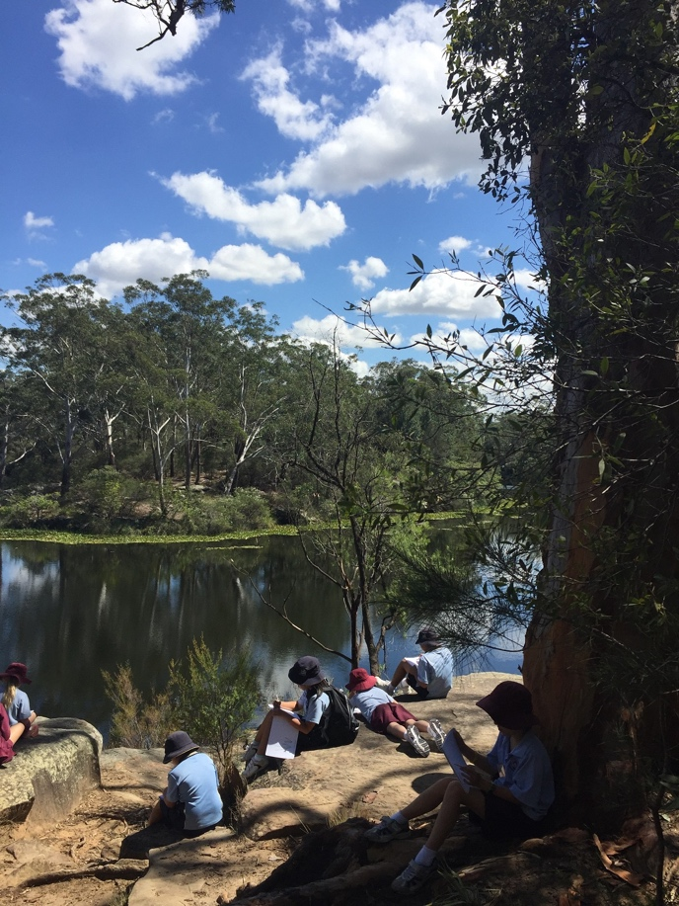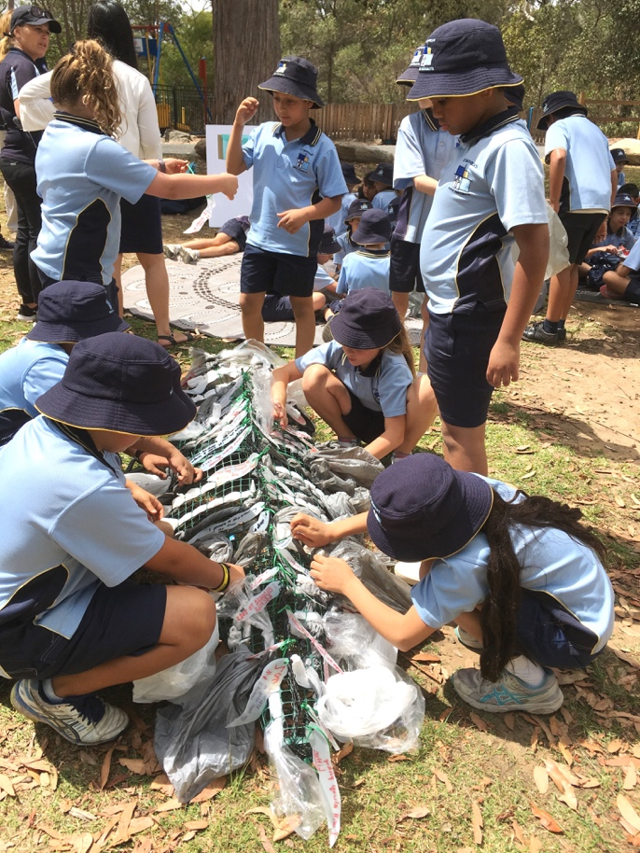
A resource developed by the
Australian Association for Environmental Education - NSW Chapter
with support from the NSW Government’s Environmental Trust
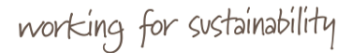
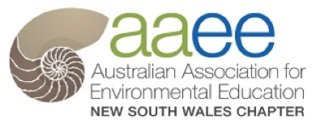
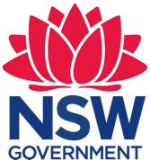
Acknowledgements
This Guide has been written by Erika Van Schellebeck with the AAEE NSW Make the Change Project Management Group of Jem Hansen, Sue Martin, Melissa Sellen, Niki Carey, Angela Colliver and Joanne Tulau, with input from Paul Brown from the University of NSW and the following staff from the NSW Office of Environment & Heritage: Richard Davies, Uncle Mark Flanders, Andy McQuie and Karen Paroissien.
This Guide extends the work of the NSW Environmental Trust and AAEE NSW wish to gratefully acknowledge the NSW Environmental Trust for permission to use and adapt their project planning information in this guide.

Copyright © 2019 Australian Association for Environmental Education- NSW Chapter

This work is licensed under a Creative Commons Attribution 3.0 licence http://creativecommons.org/licenses/by/3.0/au/

Under this licence the material is available for free use and adaptation. Educators may use, adapt, communicate and re-publish material from the resource.
Information contained in this Guide may be copied or reproduced for study, research, information or educational purposes, subject to inclusion of an acknowledgement of the source.
The following statement must be used on any copy or adaptation of the material.
Copyright: AAEE NSW 2019, except where indicated otherwise. This work is licensed under a Creative Commons Attribution 3.0 license.

Cover photographs: The Western Sydney Environmental Education Network’s 2017/18 best practice Sustainability Education and Engagement project “Mountains to the Sea”.
See https://www.aaeensw.org.au/resources for the case study of this and other projects.

How to use this guide
This guide is made up of two sections: a background to the guide (page 2-4) and a Project Plan Template with guidance notes in blue boxes (page 5-14).
An Excel spreadsheet for the project budget also accompanies this template.
BACKGROUND
This Guide was created as part of the AAEE NSW ‘Equipping Regional Sustainability Education Networks for Creating Change’ Project 2016-2018, that was supported by the NSW Government’s Environmental Trust.
The guide has been road tested by nine Regional Sustainability Education Networks from across NSW, who as part of the project used the enclosed project plan template to plan and undertake a best practice sustainability education and engagement project.
These best practice projects have been written up as case studies and can be downloaded at https://www.aaeensw.org.au/case-studies .
The principles and themes in this document have been guided by the Make the Change: A Framework for Education and Engagement for Sustainability 2014-2021, the NSW Environmental Trust Environmental Education Grants Program and Expression of Interest Guidelines (2016) and resource What makes a good objective?, as well as Does Your Project Make a Difference? A guide to evaluating environmental education projects and programs.
Sustainability education and engagement
For our country, for our people and for our economic and social viability, it is essential that all of us living in NSW protect and enhance our environment and strengthen our communities.
We need to act more sustainably at home, in our workplaces and communities, and during our recreation.
Education and engagement for sustainability are important motivators and enablers of these actions- they help people to understand and do more for our environment.
Best practice guiding principles
Best practice sustainability education and engagement projects:
- Operate within and promote the values of sustainability - defined as ‘balancing the community’s economic and social needs within the planet’s ecological limits’;
- Encourage the community to be active citizens in caring for our environment;
- Respect and reflect local Aboriginal culture and heritage and include cultural and place-based learning;
- Reflect and address the needs of target audiences and engage these participants through critical thinking, problem solving and action;
- Have reflection, monitoring and evaluation built into their design, to allow for continuous improvement;
- Are achieved by seeking collaborators from the target audience, local Aboriginal community and organisations from different sectors
These are adapted from the guiding principles of Make the Change: A Framework for Education and Engagement for Sustainability 2014-2021 and based on the principles of Education for Sustainability (EfS).

Make the Change- the NSW framework for sustainability education and engagement
Make the Change is a framework that provides a unified, coordinated and collaborative approach to sustainability education and engagement across NSW.
The framework was developed by AAEE NSW in partnership with NSW Office of Environment and Heritage (OEH) and was based on research and an extensive consultation process.
It continues on from the NSW Government Environmental Education Plan ‘Learning for Sustainability’ 2007- 2010.
Based on international best practice research and extensive stakeholder consultation, Make the Change defines the shared vision, principles and goals that will support sustainability education and engagement providers from all sectors to shape effective action into the future.
It establishes a new way forward for Education for Sustainability in NSW and provides a framework that recognises regional, rural and urban issues and works within principles and practices important for 2014 and beyond.
Education for Sustainability- a global approach
Education for Sustainability (also known as Education for Sustainable Development) is an internationally recognised educational approach that moves beyond just imparting knowledge about the environment – educating about sustainability – to building people’s capacity for transformational change – educating for sustainability. It focuses on motivating and engaging people to help create a better future.
Below are the five components of Education for Sustainability as defined by the Australian Research Institute for Environment and Sustainability (ARIES) at Macquarie University:
1. Envisioning
Envisioning a better future (or Futures Thinking) creates a link between where we are now and where we want to be in the future, so we can plan a series of steps to get us there.
2. Systems Thinking
Systems Thinking can help us to understand the big picture we are working within, and to create solutions that go beyond just addressing the isolated symptoms of a larger problem.
This means equipping people to understand connections between environmental, economic, social and political systems.
3. Critical Thinking
Critical Thinking and reflection challenges us to examine and question the underlying assumptions that affect the way we interpret the world.
4. Participation
Participation goes beyond consultation, to empowering people by directly involving them in the decision-making process. Engaging people in decision-making creates a greater sense of ownership and commitment, both of which mean they are more likely to take action.
- It puts decision-making and responsibility for outcomes in the hands of participants;
- It builds capacity for self-reliance and self-organisation;
- When everyone is actively involved in the challenge, amazing results are achievable.

5. Partnerships
Creating partnerships for change strengthens ownership of a problem and a commitment to sustainability amongst diverse stakeholders.
- Workloads are shared;
- A greater skills base is accessed;
- It promotes learning how to work together to build a shared vision of the future by combining knowledge, technology and resources;
- It also recognises that one of the best ways to understand different world views is to collaborate with people from different cultures and backgrounds.
Best practice- helping to achieve the United Nations 2030 Agenda for Sustainable Development
In recognition of the importance of Education for Sustainability, the United Nations declared 2005-2014 as the UN Decade of Education for Sustainable Development (ESD).
In 2015, Heads of State, Government leaders, UN High Level Representatives and civil society met at the 70th Session of the United Nations General Assembly and adopted the Sustainable Development Goals (SDGs). In 2016, the 17 Sustainable Development Goals (SDGs) of the 2030 Agenda for Sustainable Development officially came into force.
These goals apply universally to all and aim to mobilize countries to end all forms of poverty. They call for action by all countries, poor, rich and middle-income, to promote prosperity while protecting the planet. They recognize that ending poverty must go hand-in-hand with strategies that build economic growth and address a range of social needs including education, health, social protection, and job opportunities, while tackling climate change and environmental protection.
Education for Sustainable Development (ESD) is recognized as a key element of quality education and a crucial enabler for sustainable development. The Sustainable Development Goals (SDGs) adopted by the global community recognize the importance of education in achieving their targets by 2030.
Target 4.7 of the UN Sustainable Development Goal 4 on education specifically addresses ESD and related approaches.
Target 4.7 Education for Sustainable Development and Global Citizenship:
“By 2030, ensure that all learners acquire the knowledge and skills needed to promote sustainable development, including, among others, through education for sustainable development and sustainable lifestyles, human rights, gender equality, promotion of a culture of peace and non-violence, global citizenship and appreciation of cultural diversity and of culture’s contribution to sustainable development.”
The Global Action Programme on Education for Sustainable Development is the follow- up programme to the Decade of ESD (2005-2014) and seeks to generate and scale-up ESD and to accelerate progress towards sustainable development. This programme aims to contribute substantially to the 2030 agenda, through two objectives:
- Reorienting education and learning so that everyone has the opportunity to acquire the knowledge, skills, values and attitudes that empower them to contribute to a sustainable future.
- Strengthening education and learning in all agendas, programmes and activities that promote sustainable development.
PROJECT PLAN TEMPLATE
Contents
PROJECT TITLE & SUMMARY 6
ENVIRONMENTAL BENEFIT 6
What environmental issue are you addressing and why is your project is needed? 6
What environmental benefit/s will occur if your project is successful? 6
Are there any related projects you are aware of that have addressed this issue and if so, how will their key learnings inform your project? 6
TARGET AUDIENCE 6
Who is the target audience for your project? 6
Why do you think targeting this audience will tackle the environmental issue you are addressing? 7
PROJECT ACTIVITIES 7
How will your activities educate participants about sustainability?.............................................................7
How will your target audience benefit from participating in your project activities? 7
How do your project activities build the capacity of your audience?...........................................................8
Outline the activities you are going to undertake to educate and engage your target audience 8
COLLABORATION 9
List your project team, how each collaborator will help deliver the project and how the project will help deliver their organisation’s long-term goals 10
STAKEHOLDERS & COMMUNICATION 10
Identify your stakeholders, their interests in the project and your communication strategy for them 10
EFFECTIVENESS(EVALUATION) 11
List your sustainability education & engagement project outcomes 12
Outcomes Hierarchy Framework Template 13
When will you reflect on your outcomes and who will be involved? 14
DISSEMINATION 14
How will you share your project’s education and engagement outcomes with others? 14
BUDGET 14

PROJECT TITLE
A good project title should be short and snappy to capture people’s imagination- 5 to 6 words is ideal.

[Write your project title here]

PROJECT SUMMARY
Write this summary once you have completed the rest of this project plan
A summary is critical for your project communications and should not include jargon or terms specific to your industry.
- It should clearly explain the project in a way that both resonates with your target audience and makes sense to anyone ‘on the street’ who might read it.
Be concise: 3 to 6 sentences or approximately 100 words.

[Write your project summary here]

ENVIRONMENTAL BENEFIT
Best practice sustainability education and engagement projects do not stop at education.
They use education to engage the community to take action to care for the environment, that results in a tangible environmental benefit.
Education and engagement projects may be complemented by other activities (e.g. enforcement).

What environmental issue are you addressing and why is your project is needed?
[Write your response here]

What environmental benefit/s will occur if your project is successful?
[Write your response here]

Are there any related projects you are aware of that have addressed this issue and if so, how will their key learnings inform your project?
[Write your response here]

TARGET AUDIENCE

Who is the target audience for your project?
Be as precise as possible in describing your audience e.g. residents of x suburb who own cats, food businesses (including takeaway shops, cafés and restaurants) in x, y and z streets of x town.

[Write your response here]

Why do you think targeting this audience will tackle the environmental issue you are addressing?
Include any data or research you are aware of, or any consultation you have done with stakeholders, that indicates that targeting this audience will help to successfully address the environmental issue.

[Write your response here]

PROJECT ACTIVITIES
How will your activities educate participants about sustainability?
Your activities need to educate and engage your participants about the values of sustainability- defined by the Make the Change framework as ‘balancing the community’s economic and social needs within the planet’s ecological limits’.
This means taking a ‘systems thinking’ approach to your education and exploring the big picture, so that your participants can create solutions that go beyond just addressing the isolated symptoms of a larger problem.
E.g. A campaign to encourage café owners to stop using plastic straws should include information about the bigger problem of single-use plastics, its impacts on our oceans and waste management systems and the political movement to ban single-use plastics etc.
Exploring the connections between environmental, economic, social and political systems with your participants empowers them to critically think about other environmental issues and how they might be solved.

[Write your response here]

How will your target audience benefit from participating in your project activities?
For your education & engagement activity to be a success, it has to meet the needs of your target audience.
This means that your activity is designed to suit their typical behaviours and characteristics.
E.g. If your target audience is women and men aged 30-50 years, holding an activity on a weeknight from 5:30pm-7:30pm would be inappropriate, as many of your target audience need to be at home cooking dinner and getting their children into bed. Thus an activity at this time may not meet their needs. However, a family-friendly activity held outdoors on a Saturday afternoon from 2-4pm may better meet their need to relax and spend time with their family.
So if your project’s activities meet the needs of your target audience, it follows that at the end of your project both our environment and your community will have benefited.
Articulating and marketing these personal benefits i.e. “what’s in it for me?” is critical to ensuring your target audience attend your activities. (See also ‘Stakeholders & Communication’).
Examples of personal benefits include: saving money; getting exercise; eating delicious food; having fun; making new friends; meeting a potential new partner; learning a new skill; getting outdoors or spending time in nature; spending time with family and friends; feeling more connected to your community; feeling that your actions have made a positive difference to your environment.
[Write your response here]
For information on how people are more inclined to take action when they feel their action will make a difference (this is referred to as ‘perceived efficacy’ or effectiveness), please see the NSW Office of Environment & Heritage Social Research Series Who cares about the Environment in 2012?

How do your project activities build the capacity of your audience?
For your education & engagement program to successfully lead to long-term behaviour change, your activities need to increase the skills and capacity of your target audience.
This means that your activities not only educate your audience so they learn something new (increase their knowledge about an environmental issue), but also learn new skills (increase their capacity) to take on-going action to care for our environment.
E.g. If your activity is a tree planting day, you would educate your audience about why we need to plant trees and show them how to plant trees. You would also educate them on the species they should plant in their backyard and give them a list of local plant nurseries that sell those species, or even give them a free plant to take home and plant.
[Write your response here]

Outline the activities you are going to undertake to educate and engage your target audience
Activity | Target  E.g. Number of participants | Actions required to complete activity | Who is responsible? | Completion date

For information on how to design behaviour-change programs and use community-based social marketing techniques, please visit the ‘Resources’ section of our website at www.aaeensw.org.au

COLLABORATION
Best practice sustainability education projects are the result of collaborating with the target audience, local Aboriginal community and organisations from different sectors.
E.g. local councils working not only with other local councils, but also with other sectors such as schools, community groups, state government etc.
Why collaborate?
A collaborative project gains additional valuable resources from each collaborator/ partner, including:
- Time - “Many hands makes light work”;
- Knowledge of:
  - Your target audience and their needs;
  - Networks – individuals and/or organisations who can help your project in some way;
- Skills and expertise in:
  - Project design;
  - Community engagement and communications:
    - Facilitation and event organisation;
    - Media liaison;
    - Graphic design and photography;
    - Social media skills (creating e-newsletters and Face book posts etc).
  - Evaluation;
  - Dissemination- how you are going to share what you did and what you learnt with each other sustainability educators;
- Materials (use of cameras, vehicles, venues, funding etc).
To ensure your collaborators take ownership of the project it is vital that they are all involved in the project design. This involves inviting them to review the first draft of the project plan and incorporating their ideas and concerns into the final plan.
The project management time required to ensure all collaborators understand and fulfil their roles will be far outweighed by the benefits of all of the resources they bring to a project.
Collaboration also helps to ensure that your project is “not re-inventing the wheel” and integrates the lessons learned from other sustainability education projects.

Involving your target audience
Most sustainability education and engagement project ideas come from needs identified through consultation with the target audience. These can include formal consultations for a Strategy or Plan, or informal conversations or meetings.
Participation however goes beyond consultation, to empowering people by directly involving them in the decision-making process. This creates a greater sense of ownership and commitment and makes citizens more likely to take action.
Inviting a representative from your target audience to collaborate on your project design ensures participatory decision-making and gives you confidence that your project activities will be attended.
Find your target audience representatives by contacting community groups (including mothers groups, Parents & Citizens Associations, sporting clubs and Rotary groups), schools, Local Aboriginal Land Councils, chambers of commerce or Landcare groups etc.

Involving your local Aboriginal community
It is essential to connect with your local Aboriginal community from the beginning, to ensure your project respects and reflects local Aboriginal culture and heritage and includes cultural learning.
Start by having a conversation with a representative of your local Aboriginal community to:
- Share your project rational;
- Find out their perspective on the problem and possible solutions;
- Identify who from the Aboriginal community may wish to be invited to be involved.
If your organisation does not have an Aboriginal Liaison Officer, contact your Local Aboriginal Land Council to find out the best way to consult with your local Aboriginal Elders Group.

List your project team, how each collaborator will help deliver the project and how the project will help deliver their organisation’s long-term goals
- The project team involves a representative from the target audience [tick if applicable]
- The project team involves a representative from the local Aboriginal community [tick if applicable]
Name | Position | Project Role | Organisation | Organisational goals this project addresses

STAKEHOLDERS & COMMUNICATION
Stakeholders are any people or groups who are interested in, concerned about, or affected by the issue your project is addressing and/or your project and its outcomes.
They include your target audience and the organisations your project team/collaborators represent.
A communication strategy helps you get your message out to your audience and stakeholders and ensures that these groups know about your project.
As discussed in ‘Project Activities’, ensure that the key message for your target audience clearly promotes the personal benefits to be gained from being involved, not just the environmental benefits.

Identify your stakeholders, their interests in the project and your communication strategy for them
[Delete the notes and examples in this table to develop a Communication Strategy for your project]
Stakeholders | Interest | Key message | Communication method
Target audience | E.g. Can benefit from being involved. | [This should motivate your target audience to get involved.]  E.g. “Come to our x activity and you will gain the following personal benefits…” | E.g. Email, phone call, visit, doorknock, letterbox drop, flyer, information stall etc.
Project Team and their Organisations | E.g. Want the project to succeed and get credit for their hard work. | [This should promote the work of the project team so that their organisations are acknowledged for allowing their staff to be involved and are encouraged to collaborate on future projects.]  E.g. “The following organisations are working collaboratively on the x sustainability education project and are achieved the following outcomes…” | E.g. Briefing or report to Management of Project Lead, that can be circulated to collaborating staff and their Managers etc.
General community | E.g. Live or work in your project area. | This should increase awareness of the issue your project is addressing  E.g. “The x project is helping our local community and environment by …” | E.g. Media release, e-newsletter, social media post etc.
Other stakeholders

EFFECTIVENESS(EVALUATION)
Establishing what you want your project to achieve and how you will measure this is critical to your project’s effectiveness/success.
Project Outcomes
Your outcomes should be focussed on what you want to achieve rather than what you have to do.
The SMART approach (below) is a helpful tool for designing a project that is outcome focussed.
Specific: Outcomes should be clear, well defined and unambiguous.
Measurable: Outcomes should be measurable so that you can demonstrate it has been achieved. If an outcome is not measurable, it is not possible to know whether you are on track and have achieved the outcomes at project completion.
Attainable: Outcomes should be realistic and achievable. Agreement and commitment from relevant stakeholders is a must to ensure outcomes can be reached.
Resourced: Outcomes should be suitably resourced. Resources include access to individuals with relevant skills and knowledge as well as the necessary tools.
Time bound: Outcomes should be achieved within a certain timeframe. This ensures commitment to a deadline so you know where you want to get to and by when.

List your sustainability education & engagement project outcomes:
These are the ultimate, intermediate and immediate outcomes from your Outcomes Hierarchy table on the following page.

Outcomes Hierarchy Framework
An Outcomes Hierarchy Framework is an important monitoring and evaluation tool for sustainability education and engagement projects and shows the logic of a project.
It does this by demonstrating how your activities will achieve your project’s outcomes and how this will be monitored and evaluated (as discussed in ‘Indicators of Success’ below).
On the next page is a template to assist you to develop an Outcomes Hierarchy Framework for your sustainability education and engagement project.
For detailed information on how to create an Outcomes Hierarchy Framework, including step by step case study examples of developing evaluation questions and indicators of success, please refer to Does Your Project Make a Difference? A guide to evaluating environmental education projects and programs.
Indicators of Success
How are you going to measure if your outcome is being achieved?
To effectively measure success it is best to establish a baseline to compare any changes that occur as a result of your project.
This could be of knowledge, attitudes and current practice.
E.g. When planning a litter education project you would measure the baseline of how much litter is in your target area, to be able to demonstrate a reduction in litter as a result of your project.
For some projects you may even be able to access environmental baseline data.
Using the same example as above, if there was water quality data available for the creek downstream of the litter reduction target area, you may be able to measure water quality improvements as a result of your education project.
What will success look like if your outcome is achieved?
Most projects should incorporate both quantitative (numerical – how much did we do?) and qualitative indicators (descriptive – how well did we do it?).
Indicators should always demonstrate a tangible environmental benefit.
They may also look at social and economic benefits.

Outcomes Hierarchy Framework Template
This table shows the ‘program logic’ of your sustainability education & engagement program – i.e. how your project’s activities will help our environment. It is read from bottom to top.
- It shows how your project activities will lead to an immediate outcome, which will then lead to an intermediate outcome that results in the ultimate outcome of a protected/enhanced environment.
[Delete the notes and examples in this table to develop an Outcomes Hierarchy Framework for your project]
Outcomes Hierarchy | Measures |  | DATA sources & COLLECTION  (E.g. observations, counts, surveys)
 | Evaluation questions | Indicators of success
Ultimate outcome
[Write a one-sentence statement describing how our environment has benefited from your project] | E.g. Did your project help the environment? | E.g. No. of trees planted, m² of land revegetated or regenerated, litres of water saved, kg of CO² reduced, kg of waste diverted from landfill, kg of litter/marine debris collected. | E.g. Observations, counts- X project team member to collect on x date.
Intermediate outcome
[Write a one-sentence statement describing how your target audience has changed their behaviour] | E.g. Did your target audience change their behaviour and take action? | E.g. Percentage of participants who adopted a new behaviour (took action). | E.g. Follow-up survey of participants- X project team member to undertake by x date.
Immediate outcome
[Write a one-sentence statement describing the commitment to take action that has been taken by your audience] | E.g. Did your target audience make a commitment to take action? | E.g. Number of commitments to take action. | E.g. Survey of participants at end of activity/ no. of pledges signed to take action- X project team member to collect at x activity below.
Activities
[List each activity that will educate & engage your target audience]  Tip: write each activity in a separate row to ensure each are evaluated. | E.g. Was your activity a success? Did your target audience learn from the activity? | E.g. Number of participants. % of participants who were your target audience. Increase in knowledge of participants. | E.g. Attendance records. Survey of participants at start and end of activity- X project team members to collect at activity.
* Outcomes Hierarchy Frameworks traditionally have a ‘Needs’ row underneath ‘Activities’, however we have removed this because it is covered in the Environmental Benefits section of this plan.

Reflection
Reflection is critical to the success of your project and therefore needs to be undertaken throughout your project, not just at the end.
This allows for continuous improvement based on review and is referred to as “using a feedback loop” or “adaptive project management”.
E.g. If your evaluation shows that a project activity did not result in the immediate outcome as planned, your project team will need to re-think and adapt your program logic so that the intermediate and ultimate outcomes can still be achieved.
As they say “a stitch in time saves nine” and if you do not reflect regularly throughout your project, you risk discovering problems when it is too late to stop them from impacting on the success of your project.
TIP 1: Allow time in each project team meeting to stop and reflect on what has happened, then plan for what has to happen.
This will ensure you can identify any problems while you still have time to solve them.
TIP 2: A debrief with staff/volunteers immediately or soon after an event can help you to capture insights that may otherwise be forgotten by the time you have your next project team meeting.

When will you reflect on your outcomes and who will be involved?
[Write your response here]

DISSEMINATION

How will you share your project’s education and engagement outcomes with others?
Include your approach and any documents/resources you may develop (e.g. a report to management, media release, project case study, film etc.)
If you plan on developing a case study please refer to Write it up! A guide to writing Sustainability Education Case Studies .

[Write your response here]

BUDGET
The Budget Excel spreadsheet that accompanies this plan is based on the information required for NSW Environmental Trust funding applications.
Please use it to outline your project budget and estimate the in-kind contributions of your project team/collaborators. Please adapt it to suit the requirements of your organisation or funding body.
In-kind contributions include:
- The estimated time your collaborators will spend working on the project (their hourly salary or $40/hr for volunteers);
- Materials given to the project (cost of the materials if you had to buy them);
- Materials loaned to the project (hourly cost of hiring those materials).

http://aries.mq.edu.au/about/education_for_sustainability_processes/
http://aries.mq.edu.au/about/education_for_sustainability_processes/
https://www.un.org/sustainabledevelopment/development-agenda/
https://en.unesco.org/gap

