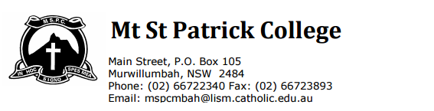

Dear Parents,

As a result of accidental damage to your son’s/daughter’s laptop, a $55 excess fee for repairs has been incurred. You are asked to repay the $55 to the front office within a month of the date noted below or your child’s laptop will be confiscated until the payment is made. Only one accidental damage claim is permitted per year. If your son/daughter accidently damages the lap top again within this calendar year, you will be required to pay the full amount of repair costs, as noted in the HP correspondence below:

“For HP commercial and consumer products, accidental damage protection is limited to 3 parts per product per calendar year with excess of A$55 (plus GST) per claim. Once the specified limit is reached, the cost of repair for any additional claims will be charged on a time-and-materials basis.”
Thanking you in anticipation of very limited accidental damage claims.
Natalie Webster
Network Co-ordinator

Student Name:_________________________
Year:_________ Homeroom:_______
Date of laptop collection from IT office____________
Payment due date_____________
I understand that my son/daughter _______________________ is required to pay the $55 excess repair fee for their laptop.

Parent/Guardian Name:________________ Parent/Guardian signature: ______________

