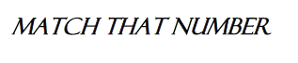
Write your answers for each part in the space below.
Step | Number | Working and answer
Starting number | 100 | --------------------------------
1
2
3
4
5
6
7
8
